British Council presents Predicting History: Testing Translation, Lubaina Himid’s major installation for the British Pavilion at the 61st International Art Exhibition, La Biennale di Venezia
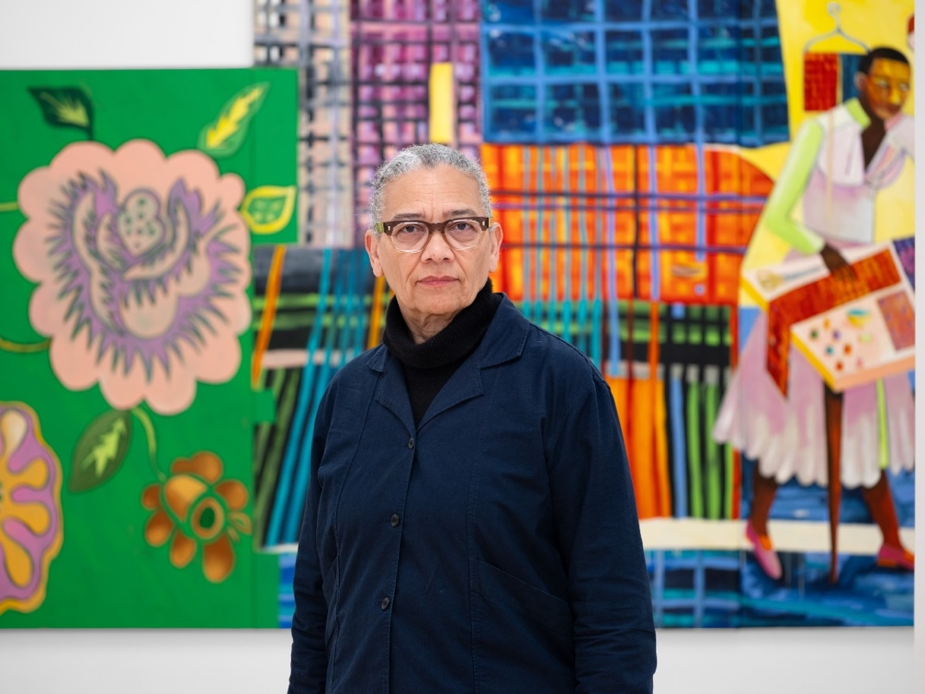
Lubaina Himid CBE RA at the 61st International Art Exhibition – La Biennale di Venezia. © Photo: Eva Herzog
Credits: The British Pavilion is commissioned by the British Council – please credit the British Council in all editorial features and photographer, Eva Herzog for image rights.
The British Council unveils Predicting History: Testing Translation, a major new installation by Lubaina Himid for the British Pavilion at the 61st International Art Exhibition – La Biennale di Venezia.
In this new installation, Himid explores what it means to make a home in a new place. The exhibition brings together large-scale, multi-panel paintings alongside works on found objects, ‘kanga’ paintings, and a soundscape made in collaboration with artist Magda Stawarska. Combined, these form an immersive experience that questions what it means to inhabit a space not built for you, and to assert oneself in a world where some can move freely while others are ‘out of place’. The architecture of the British Pavilion itself serves as a symbol of the UK, while the exhibition combines sound, text and imagery to offer a layered exploration of place and home.
Informed by her background in theatre and love of opera, Himid transforms galleries into immersive, multi-sensory spaces with a theatrical energy, encouraging visitors to engage emotionally with the characters in her work and their actions, as they would in a dramatic performance. Her five large-scale paintings – Architects, Tailors, Chefs, Boatbuilders and Gardeners – present surreal settings where industrious figures gather in negotiation. The title characters talk intently to one another, working through the practical and creative challenges of adapting to an unfamiliar environment. The title Predicting History: Testing Translation points to uncertainty and interpretation, while Himid describes the exhibition as a guide to navigating life and belonging beyond one’s roots, and to understanding what home can mean.
Using the Pavilion to symbolise Britain, visitors experience it as welcoming and airy, brimming with potential. However, subtle sounds, texts and imagery introduce moments of unease to an environment that otherwise evokes an idyllic British summer's day. Paintings ask unsettling questions such as Can Flies Settle Here or Can Poison Taste Delicious, while Nana Mouskouri singing the folk song Early One Morning adds notes of melancholy and loss. The Pavilion's neo-classical architecture, often read as a symbol of authority and permanence, becomes a site of reflection where national and personal identities can be explored.
In Architects – the first painting visitors encounter – two figures debate how to construct a safe place of belonging. Alongside architectures from different climates, belief systems and histories (an igloo, a beehive, a church, a mosque), one figure in bright period clothing holds a solid, cylindrical model home offering privacy, while another in elaborate fringed or feathered attire offers an alternative on wheels, ready to escape if needed.
Water and the ocean have been a recurring theme in Himid’s work for decades, carrying the history of British sea power upon which the empire and slave trade depended. In Boatbuilders two well-dressed figures stage an animated debate before a model boat, weighing their options. As Himid has said, those who come from elsewhere are continually negotiating belonging: deciding whether to integrate into the new place or live with the friction that difference produces. Nearby, painted wooden oars evoke Venice's maritime history of trade and exchange. Looking toward the lagoon beyond, they create the illusion of escape, as if one might simply sail away, yet their mismatched forms quietly insist that such departure is impossible. On the opposite wall, Man in a Rope Drawer shows a face glancing out toward the water. The installation creates subtle interplay between the histories of Britain and Venice – the lagoon symbolising the Venetian Empire, visible from a British Pavilion first opened in 1909 when Britain's own empire was at its height.
Several works continue Himid's ongoing series drawing on East African kangas: patterned textiles traditionally worn by women, often humorous or satirical, featuring central imagery with proverbs carrying coded social meaning. By adopting this format, Himid treats language as lived communication, moving between bodies, histories and settings.
Following the Biennale, the commission will tour select venues in the UK with support from Art Fund.
Lubaina Himid said: “This has been an extraordinary opportunity to work with the British Pavilion, and I look forward to visitors entering the space and listening to their own thoughts and memories, connecting with my installation in a way that feels alive with possibility. Predicting History: Testing Translation grows out of my urgent interest in how we make a home, especially in places not designed to welcome us. I hope those that experience the installation in Venice, and those who encounter it on the tour to Coventry, Belfast and Swansea, will find it to be a space where ideas about belonging can be shared, tested and reimagined together.”
Emma Dexter, Director Visual Arts and the British Council Collection and Commissioner of the British Pavilion, said: “Lubaina Himid has created a magisterial installation for the British Pavilion. Animating the whole building with spectacular paintings and intriguing sounds, she has made it a space to examine Britain itself. Throughout the installation, timeless figures debate with each other while constructing new lives for themselves. As commissioner, the British Council is proud to support a work that explores belonging, challenges familiar narratives, and offers a timely reflection on a UK defined by many perspectives.”
Ese Onojeruo, Shane Akeroyd Associate Curator of the British Pavilion, said: “Predicting History: Testing Translation sits in the space of working things out together. It asks us what it means to build together, adapt and make a home in a place not built for you. It has been a privilege to work closely with Lubaina Himid on this installation; her practice, rooted in care, dialogue and a thoughtful approach to space, has shaped the work profoundly. Her work resists easy answers, instead opening space for generous and thoughtful conversations, grounded in a strong belief in art’s power to change how we see the world and our place within it. I’m grateful to the British Council for the opportunity to help bring this vision to life.”
Ruth Mackenzie, Director of Arts at the British Council, said: “It is a joy for us all at the British Council to be working with Lubaina Himid on her new commission for the British Pavilion which explores so beautifully how our understanding of home, migration, shared histories shape our identities and our view of our country. Her work is both personal and will resonate with all visitors to the British Pavilion from any country in the world.”
Art Fund is generously supporting the commission and the tour bringing the installation to UK venues. The venues and dates are: The Herbert Art Gallery and Museum (12 February – 23 May 2027), The MAC Belfast (11 June – 22 August 2027), Glynn Vivian Art Gallery (24 September 2027 – 9 January 2028).
Jenny Waldman, Director of Art Fund, said: "The tour of Lubaina Himid's remarkable installation will bring her exploration of home and place to people across the UK, in new contexts and closer to their own homes. We are delighted to continue our longstanding support of the British Council commission and UK tour, and to be offering audiences the opportunity to engage with the exceptional works created by British artists for the Venice Biennale.”
Supporting Partners are Frieze, in its second partnership with the British Council Commission for the British Pavilion; Cork Street Galleries – an initiative of The Pollen Estate; the Henry Moore Foundation; Rothschild Foundation; the Girlfriend Fund; and our digital partner Bloomberg Philanthropies.
Eva Langret, Director of EMEA, Frieze said: “The Venice Biennale is a moment when all eyes are watching, and Himid's practice, weaving personal stories with global histories, holding questions of home, belonging and memory with rare clarity and care, meets it with extraordinary force. We're delighted to be supporting the British Pavilion once again, and to play a part in realising her vision there.”
Significant support comes from the Himid Circle: Jill Hackel and Andrzej Zarzycki; Elia Mourtzanou; Suzanne McFayden, Nelumbo Collection; Cingilli Collection; Hollybush Gardens; Greene Naftali; and from Shane Akeroyd and the British Council’s Ambassador Circle and Global Circle.
ENDS
Contact
For media enquiries regarding the British Council’s commission for the British Pavilion please contact: Mary Doherty / mary@sam-talbot.com or Richard Evans / richardjames.evans@britishcouncil.org
Credit
The British Pavilion is commissioned by the British Council – please credit the British Council in all editorial features.
Exhibition details
The British Pavilion is commissioned and managed by British Council Arts.
Commissioner: Emma Dexter
Curator: Ese Onojeruo
Lubaina Himid’s British Council Commission for the British Pavilion at La Biennale di Venezia will run from 9 May – 22 November 2026.
Preview: Wednesday 6 – Friday 8 May 2026, 10am-6pm
For news on the British Council commission: venicebiennale.britishcouncil.org/
About the British Council
The British Council is the UK’s international organisation for cultural relations and educational opportunities. We support peace and prosperity by building connections, understanding and trust between people in the UK and countries worldwide. We do this through our work in arts and culture, education and the English language. We work with people in over 200 countries and territories and are on the ground in more than 100 countries. In 2024-25 we reached 600 million people.
About Lubaina Himid, RA, CBE
One of the pioneers of the Black British Art Movement, Himid curated several significant exhibitions in the 1980s and 1990s, such as Five Black Women (1983) at the Africa Centre, London and The Thin Black Line (1985) at the Institute of Contemporary Arts (ICA), London, both of which showcased the work of Black female artists in response to their exclusion from mainstream galleries. In 2025, Himid reimagined this iconic exhibition at the ICA, expanding contemporary interpretations and conversations around art making.
Himid has a profound interest in the materiality and performativity of painting, shaped by her degree in Theatre Design obtained from Wimbledon College of Art. This approach can be seen in her cut-outs, figurative paintings created on freestanding shaped board which allow viewers to walk among them. A Fashionable Marriage (1986) is an early installation that critiques race, gender and class, drawing inspiration from William Hogarth’s satirical paintings. Other notable works include Naming the Money (2004), consisting of 100 life-size cut-outs which reimagines the lives of enslaved and forgotten Black figures in European history and Swallow Hard: The Lancaster Dinner Service (2007), a collection of overpainted ceramic pieces which addresses Britain’s involvement in the transatlantic slave trade. Her skillful overpainting allows her to overlay new and old histories on the surfaces of everyday objects and furniture.
Himid frequently employs storytelling and historical research, notably in the Le Rodeur series of paintings (2016–17), named after a 19th-century French slave ship infamous for a horrific event in 1819 in which captured Africans, many of whom had contracted an infectious eye disease during the voyage, were thrown overboard by the crew. The figures Himid paints in various scenarios are not obviously set in one period of time, they remind us of the past and its impact on the present. By re-examining and re-contextualising historical narratives, Himid challenges contemporary audiences to critically engage with collective perceptions of racial and cultural identity, amplifying marginalised voices and overlooked histories.
Himid’s ongoing series Men in Drawers (2017–) sees painted portraits on the interiors of found wooden drawers which transform everyday objects into vessels of historical reflection. Drawers represent concealed spaces within domestic settings; by placing Black figures inside these compartments Himid invites viewers to engage in a process of discovery. Himid created the Aunties (2023) a series of 64 individually painted and collaged narrow planks representing the ‘auntie’ – an interstitial role which honours the women in our lives who expand our understanding of kinship and family.
In the Strategy Paintings (2023) Himid delves into the complexities of problem-solving and decision-making by depicting groups of people gathered around tables discussing an issue, question or problem with symbolic objects such as lemons, teeth and gondolas.
Lubaina Himid CBE RA (b. 1954, Zanzibar) lives and works in Preston, UK and is Emeritus Professor of Contemporary Art at the University of Lancashire. She is the winner of the 2017 Turner Prize, the 2023 Maria Lassnig Prize and the 2024 Suzanne Deal Booth | Flag Art Foundation Prize. She has exhibited extensively in the UK and internationally and is represented by Hollybush Gardens, London and Greene Naftali, New York.
Recent solo exhibitions include MUDAM, Luxembourg and Kettle’s Yard, Cambridge, both with Magda Stawarska; UCCA, Beijing (all 2025); Make Do and Mend, The Contemporary Austin, Texas and The FLAG Art Foundation, New York; Barricades, Hollybush Gardens, London; Street Sellers, Greene Naftali, New York (all 2024); Plaited Time/Deep Water, Sharjah Art Foundation, UAE; What Does Love Sound Like?, Glyndebourne, Lewes (both 2023); So Many Dreams, Musée cantonal des Beaux-Arts, Lausanne; Water Has a Perfect Memory, Hollybush Gardens, London; Zanzibar, Van Abbemuseum, Eindhoven (all 2022); Lubaina Himid, Tate Modern, London (2021); Spotlights, Tate Britain, London; The Grab Test, Frans Hals Museum, Haarlem; Lubaina Himid, CAPC Bordeaux; Work From Underneath, New Museum, New York (all 2019); Gifts to Kings, MRAC Languedoc Roussillon Midi-Pyrénées, Sérignan; Our Kisses are Petals, BALTIC Centre for Contemporary Art, Gateshead (all 2018); The Truth Is Never Watertight, Badischer Kunstverein, Karlsruhe; Navigation Charts, Spike Island, Bristol; and Invisible Strategies, Modern Art Oxford (all 2017).
Selected recent group exhibitions include: Connecting Thin Black Lines 1985-2025, ICA, London; Feelings in Common, Pera Museum, Istanbul; Remember Respond Resist, The Box, Plymouth; Changes, CCA Łaźnia, Gdańsk, Poland (all 2025); Friends in Love and War – L'Éloge des meilleur.es ennemi.es, macLYON, Lyon and Ikon Gallery, Birmingham; The Time is Always Now: Artists Reframe the Black Figure, Philadelphia Museum of Art, US, The Box, Plymouth and National Portrait Gallery, London; Entangled Pasts, 1768-now, Royal Academy of Arts, London; Women in Revolt!, National Galleries of Scotland, Edinburgh and Tate Britain, London (all 2024); A Fine Toothed Comb, HOME, Manchester; A Tall Order! Rochdale Art Gallery in the 1980s, Touchstones Rochdale (all 2023); Risquons-Tout, WIELS, Contemporary Art Centre, Brussels (2020).
Her work is held in various museum and public collections including Tate, London; British Council Collection; Arts Council Collection; UK Government Art Collection; Victoria & Albert Museum, London; National Museums Liverpool; Whitworth Art Gallery, Manchester; The Women’s Art Collection, University of Cambridge, Museum Ludwig, Cologne; Musée cantonal des Beaux-Arts, Lausanne; Museum of Modern Art, Warsaw; Van Abbemuseum, Eindhoven; CAPC Musée d'art Contemporain de Bordeaux, Bordeaux; Guggenheim, New York; Guggenheim Abu Dhabi, UAE; Hammer Museum, Los Angeles; Baltimore Museum of Art, Maryland; Rhode Island School of Design, Providence and Sharjah Art Foundation, UAE.
About Art Fund
Art Fund is the national charity for museums and galleries. For over 120 years, it has helped institutions across the UK to develop and share their collections, invest in people and expertise, grow their audiences and inspire the next generation. Art Fund connects museums and people with great art and culture through funding, advocacy and initiatives, because access to art is vital for a healthy society. It champions the sector through the prestigious Art Fund Museum of the Year award – the world’s largest museum prize – and supports museum professionals through dedicated training and grant programmes. Independent and people-powered, Art Fund is supported by 142,000 members who buy a National Art Pass, as well as generous contributions from individuals, trusts and foundations. The National Art Pass offers free or discounted entry to over 1,000 museums, galleries and historic places in the UK, 50% off major exhibitions, a subscription to Art Quarterly magazine and Art In Your Inbox newsletter. For more information, visit artfund.org
About Frieze
Frieze is a leading global contemporary art organisation, recognised for its art fairs, publications and digital presence. Founded in 1991 with the launch of frieze magazine, the brand has grown to encompass eight major art fairs worldwide in cities including Chicago, London, Los Angeles, New York, Seoul, and Abu Dhabi. These events attract leading artists, galleries and collectors, fostering innovative dialogues and practices within the art community. Committed to expanding the reach and understanding of contemporary art, Frieze also hosts year-round curated programs and initiatives, including No.9 Cork Street, Frieze House Seoul, and Frieze Connect. Frieze is a MARI company. For more information, visit frieze.com
About the Henry Moore Foundation
The Henry Moore Foundation was founded by the artist and his family in 1977 to encourage public appreciation of the visual arts. Today it supports innovative sculpture projects, devises an imaginative programme of exhibitions and research worldwide, and preserves the legacy of Moore himself: one of the great sculptors of the twentieth century, who did so much to bring the art form to a wider audience. A registered charity, it awards grants to arts organisations around the world, with a mission to bring great sculpture to as many people as possible. For more information, visit henry-moore.org
About Cork Street Galleries
Cork Street Galleries is proud to support Lubaina Himid's British Pavilion at La Biennale di Venezia. An initiative of The Pollen Estate, Cork Street Galleries lies at the centre of the highest concentration of galleries in London. Since Freddie Mayor opened the first gallery on Cork Street in 1925, the street has remained at the forefront of cutting-edge art movements. As well as becoming the unrivalled hub for Surrealism during the 1930s, Cork Street launched the careers of some of the leading forces in art from the past century. Lubaina Himid has been selected for the Cork Street Galleries Banners Commission 2026/27 which will be unveiled on Cork Street in June 2026.

