Thursday 16th April 2026
UK-Malaysia Team selected for British Pavilion at the 20th Venice Architecture Biennale
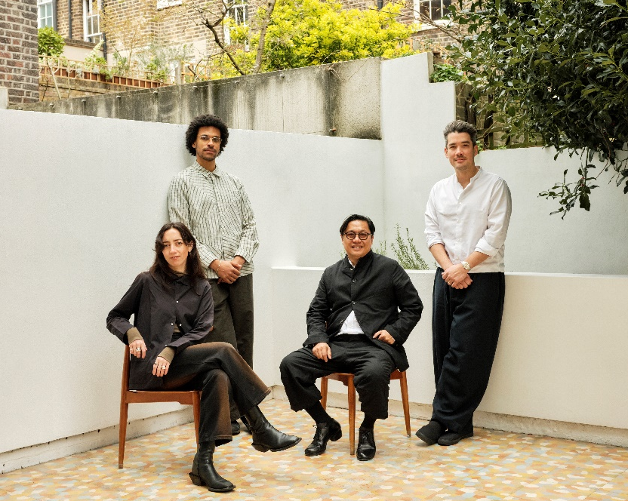
UK-based curatorial team - Maria McLintock, Ben Swaby Selig, Dr Guan Lee, Mike Lim. © Photo: Liz Seabrook
The British Council has announced the team selected to represent the UK at the 20th International Architecture Exhibition of the Venice Biennale 2027.
The 2027 British Pavilion exhibition will be a UK-Malaysia collaboration marking 70 years of diplomatic relations between the countries. This builds on the success of the UK-Kenya collaboration in the 2025 British Pavilion, which won La Biennale’s Special Mention award.
The open call for 2027 invited proposals that would challenge contemporary architecture and respond to the British Council’s UK–Malaysia Human-Nature programme, which explores relationships between people, place and the natural environment.
A panel of architects, educators and cultural professionals from across the UK and Malaysia, chaired by the Commissioner Sevra Davis, Director of Architecture Design and Fashion at the British Council, selected the team from a shortlist of six proposals.
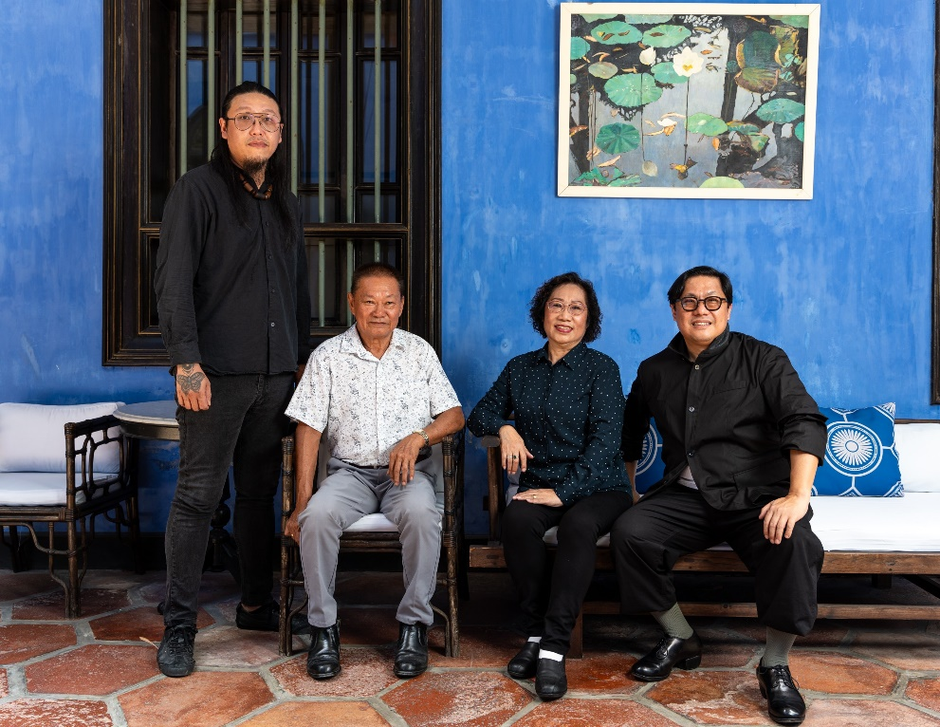
The project will be led by UK-based curators Dr Guan Lee and Mike Lim, alongside a UK curatorial team including Maria McLintock and Ben Swaby Selig. They will collaborate closely with Penang-based artisans Ng Chi Wang, Lee Shao Chin and Koh Eng Keat (see curator and artisan biographies below).

Malaysia-based artisan team - Koh Eng Keat, Ng Chi Wang, Lee Shao Chin, and Dr Guan Lee © Photo: Lim Chun Huang @ Cheong Fatt Tze, The Blue Mansion
The team’s commission will explore impermanence in architecture, diaspora culture and how migration transforms living traditions present in Malaysia and the world today.
Drawing on Malaysian traditions of ritual paper architecture - temporary structures made from recycled paper on bamboo frames - the installation will take inspiration from the Hungry Ghost Festival, where ceremonial structures are created, used and released.
Sevra Davis, Director of Architecture Design Fashion at the British Council said:
“As we celebrate 70 years of diplomatic relations between the UK and Malaysia, we are excited to work with a curatorial team whose proposal brings together architecture, ritual and cultural memory. Drawing on Malaysian traditions of paper structures created for the Festival of Hungry Ghosts, the exhibition will explore how acts of making and remaking can shape our relationships with nature, place and one another. Building on the success of the UK–Kenya collaborative exhibition for the British Pavilion 2025, I am thrilled to continue using the Pavilion as a space for cultural connection and collaboration, which lies at the heart of the British Council’s mission.”
The appointed curatorial team said:
“We are thrilled to bring the Festival of Hungry Ghosts to the British Pavilion at La Biennale di Venezia 2027, as a joyful celebration of diasporic culture and the living traditions that travel, transform, and endure through migration.
“Marking the opening and closing of the underworld, the festival is shaped by acts of care for both ancestors and wandering spirits. At its core is a construction tradition where impermanence is not a limitation but a guiding logic.
“A festival within a festival, this living ritual has travelled to Malaysia and now to Venice, transforming with each passage. To build for disappearance is, we believe, one of the most radical acts of architectural thinking available today.”
Jazreel Goh, Country Director Malaysia, at the British Council said:
“The UK-Malaysia collaboration at the 2027 Venice Biennale presents an exciting opportunity to celebrate creative collaboration between the UK and Malaysia on the global stage on the occasion of 70 years of diplomatic relations between the two countries. The appointed team’s ambition to use the exhibition as a means of exploring ritual architecture, migration and regenerative design is both timely and relevant.”
Pei Tsen Yeoh, Director of YTL Construction, and part of the selection committee said:
“After a rigorous two-stage application process, I am delighted that the successful proposal for the UK-Malaysia collaboration for the British Pavilion 2027 presents a sensitive, joyous and culturally grounded plan which successfully integrates conceptual ambition with practical delivery. By positioning ritual architecture as a model for a regenerative future, the project offers both poetic resonance and contemporary relevance to British, Malaysian and global audiences.”
Biographies of appointed curators:
Dr. Guan Lee, born and raised in Malaysia, is the founding director of Grymsdyke Farm, an architectural and experimental design practice in Buckinghamshire established in 2004 as part of his PhD dissertation. He trained in architecture at the
Architectural Association School of Architecture in London. His work is shaped by an intimate engagement with culture, material, and context. He is Associate Professor at the Bartlett School of Architecture, University College London, and teaches at the Royal College of Art in London. His teaching and research advance process driven design and thinking through making and site based production. At Grymsdyke Farm, he developed Reading Design, a summer school within its pedagogical programme, positioning architecture as a form of critical and material inquiry.
Mike Lim is a British architect of mixed Malaysian heritage. He is co-founder and Director of IDK, an architecture studio based in London and Paris. Since establishing the practice in 2016 with James Pockson and Roddy Bow, he has worked on projects across the cultural sector, with a focus on developing frameworks grounded in the real economics of making. Recent projects include the David Bowie Centre at V&A East Storehouse (2025) and NIGO: From Japan with Love at the Design Museum (2026). Current practice projects include the Deep Time permanent gallery and archive at the London Museum (2028), the redesign of Level 2 of the Blavatnik Building at Tate Modern (2026), and the Korea Gallery at the V&A (2026). The studio has been recognised as one of ArchDaily’s Best New Practices (2024) and as a RIBA Journal Future Winner (2025).
Maria McLintock is a curator, writer and lecturer working across architecture and spatial practice. Formerly Curator at the Design Museum, London, where she developed major exhibitions and publications, she has also held curatorial roles at the Museum of Modern Art, New York, and Ikon Gallery, Birmingham. She was appointed curator of the Design & Crafts Council Ireland’s galleries at Collect, Somerset House (2024–25), and serves on its Expert Curatorial Advisory Panel. She teaches critical and contextual studies of spatial practice across Central Saint Martins, UAL, and the Royal College of Art. She is co-initiator of System of Systems, a multidisciplinary research and curatorial project examining the systems shaping Europe’s migration landscape, and co-editor of Managing Displacement, developed through the project. She will commence a PhD in Architecture at The Bartlett, UCL, supported by a UCL Research Excellence Scholarship.
Ben Swaby Selig is a London-based curator and sound artist, currently working at V&A East, a two-site project comprising a new museum and an open-access collections store. He is curator of the 2026 V&A East x Art Explora Commission with Jasleen Kaur, and previously co-led the Robin Hood Gardens co-production programme and curated Sound Clash. With a background in engineering (MEng, University of Bath, 2022), his research brings together material culture, technology and public engagement, shaping a practice attuned to the often invisible and inaudible connections between human and non-human worlds. He has delivered programmes, performances and installations across the UK, including at Tate Modern, the Royal College of Art and the London Design Festival, and was the 2022
Frieze x Deutsche Bank Emerging Curators Fellow and a 2025 British Council Human-Nature Fellow.
Biographies of the Malaysia-based artisan team:
Ng Chi Wang & Lee Shao Chin run Lian Yin Art in Bukit Mertajam in Penang. Master Ng, a former commercial pilot, took over the family business on his father in law’s retirement. A veteran paper and bamboo craftsperson. he has been working on Tai Su Yeah, a giant effigy measuring over 8 feet, since 1984.

Koh Eng Keat is a paper construction artist and co-director of 358 Custom Effigies Workshop in George Town, Penang, which he operates alongside his father, Koh Ah Bah. The shop, established in 1998, produces various types of traditional paper effigies, paper sculptures and custom-made products that are lifelike and impressive. One of Koh Ah Bah’s paper sculptures from the 1980’s has been exhibited at the British Museum.

The Selection Committee for the 2027 British Pavilion in Venice is:
- Sevra Davis, Commissioner of the British Pavilion and Director of Architecture Design and Fashion at the British Council (Chair)
- Dato' Hamdan Abdul Majeed, Managing Director of Think City
- Pei Tsen Yeoh, Director at YTL Construction
- Chris Williamson, President of the RIBA
- Tara Gbolade, Co-Founder of Gbolade Design Studio
- Deep Kailey, Cultural Narrator and Artistic Director
- Leonie Bell, Director of V&A Dundee
- Roisin Donnelly, Project Manager at the National Trust
- Albert Williamson-Taylor, Co-Founding Director at AKT II
ENDS
Notes to Editor
Press contact:
For interview requests and all media enquiries, including images, please contact: richardjames.evans@britishcouncil.org
To access high resolution images, please follow this link.
Dates:
The 20th International Architecture Exhibition will run from 8 May to 21 November 2027 (pre-opening on 6–7 May).
Follow updates on the #BritishPavilion on X and Instagram: @Britisharts
About the British Council
The British Council is the UK’s international organisation for cultural relations and educational opportunities. We support peace and prosperity by building connections, understanding and trust between people in the UK and countries worldwide. We do this through our work in arts and culture, education and the English language. We work with people in over 200 countries and territories and are on the ground in more than 100 countries. In 2024-25 we reached 600 million people.

